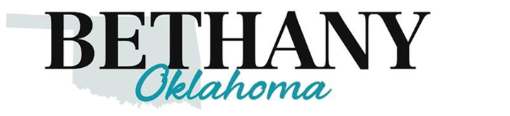

Adopt-a-Bench Program

The Bethany Parks Department has created the Adopt-a-Bench Program that allows citizens and friends of Bethany the opportunity to display commemoration of their choosing around the community. Please see Adopt-a-Bench agreement: Adopt-a-Bench agreement

Benches will be engraved on beautiful 4-foot benches. The 4-foot bench is $400 to adopt. These benches are a wonderful way to memorialize or honor a loved one. Adopt-a-Bench for a birthday, anniversary, new baby, graduation – it is a perfect gift for any occasion.

Please fill out the following
Your Name:Click or tap here to enter text. | Email Address:Click or tap here to enter text.
Phone Number:Click or tap here to enter text. | Mailing Address:Click or tap here to enter text.
Desired location for bench:Click or tap here to enter text. | Name(s) you would like displayed on the bench:Click or tap here to enter text.
Payment: Cash☐ Check☐ Visa☐ Mastercard☐ Discover☐

Payments can be made at Bethany City Hall 6700 NW 36th St.
Payment Method: Cash, Check, Visa, Mastercard, Discover
Mail: Mail (check only) to:
PO Box 219
Bethany Oklahoma 73008
405-789-2146
Email for information:specialevents@bethanyok.org

Please include the following with payment: Signed Adopt-a-Bench form (Adopt-a-Bench agreement)

